**Half-Century Mystery Solved: Missing School Bell Resurfaces**

BY RICH RODRIGUEZ THURSDAY, APRIL 25TH 2013

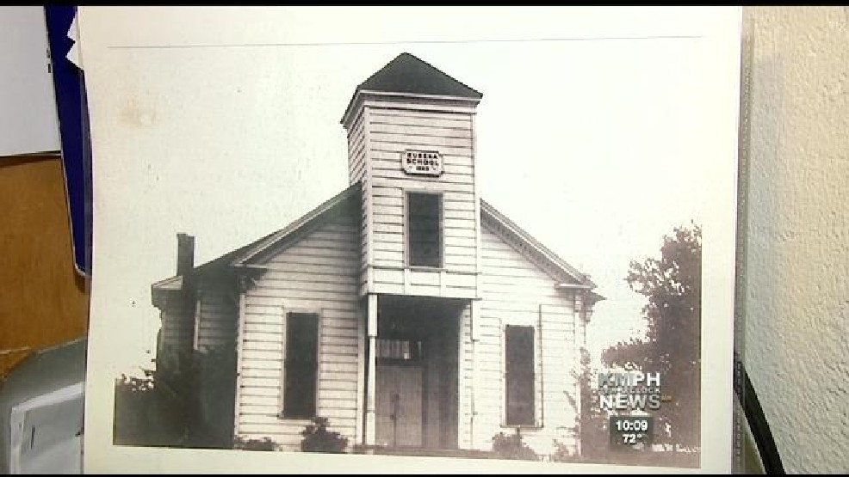

HANFORD, Calif. (KMPH) — A school bell missing for more than half a century in Hanford has been found.

Locals thought the bell was stolen when, in actuality, it had been gifted.

For years, former students who attended Eureka Elementary School thought the bell had been stolen after the school closed in 1951.{}

David Gonzales, a student at the now defunct Eureka School during the 1930's and 1940's, helped clear up this caper.

"The trustees gave the bell to Julia Tiexeira DeCampos because her sister had been teacher and principal there for quite a few years," Gonzales said.

Recently Superintendent Todd Barlow of Kit Carson School received a visit from a member of the DeCampos family.{}

"Mr. Campos said he had the old Eureka School bell and asked if he wanted it," Carson said. "Of course, I said yes."

The bell was delivered to the school.{} After undergoing a heavy sand blasting, the rust and dirt were gone.{} The bell, which is a hefty 30 inches in diameter, now looks good as new.{}

{}

Gonzales said that he remembers hearing the sound of the bell as a student.{}

"When{}I first started school [at Eureka Elementary], they had a rope coming down through the attic and down into the entrance of the school. That's the way they used to ring the bell,"he recalled.

Eureka welcomed its first class in 1893 and closed its doors for good in 1951. Gonzales created{}a marker next to a nearby alfalfa field where the school used to stand.

Students now attend Kit Carson and quite possibly on the last day of school, the century plus old bell will ring again.

The{}bell will go on display during the 60th anniversary reunion{}in May. As for a permanent place on campus, that's still up in the air.